31st October 2019
NTU staff engage in Green Rewards and donate £200 to charity
Staff staff at Nottingham Trent University (NTU) have been competing against each other to top the Green Rewards leader board, with the winning team donating £200 to Nottinghamshire Wildlife Trust. Green Rewards is a programme provided by Jump, which was launched for NTU staff in February, encouraging staff to earn Green Points by engaging in sustainability and wellbeing activities.
The 2018/19 academic year saw the Centre for Academic Development and Quality top the leader board as the most successful team. Members of Green Rewards vote for a charity to support over the year, with Nottinghamshire Wildlife Trust topping the votes for 2019.
The Trust is the county’s largest environmental charity - run by local people for the benefit of local wildlife. They manage nature reserves across the county, champion nature and inspire adults and children about the natural world, working to create a Living Landscape for Nottinghamshire.
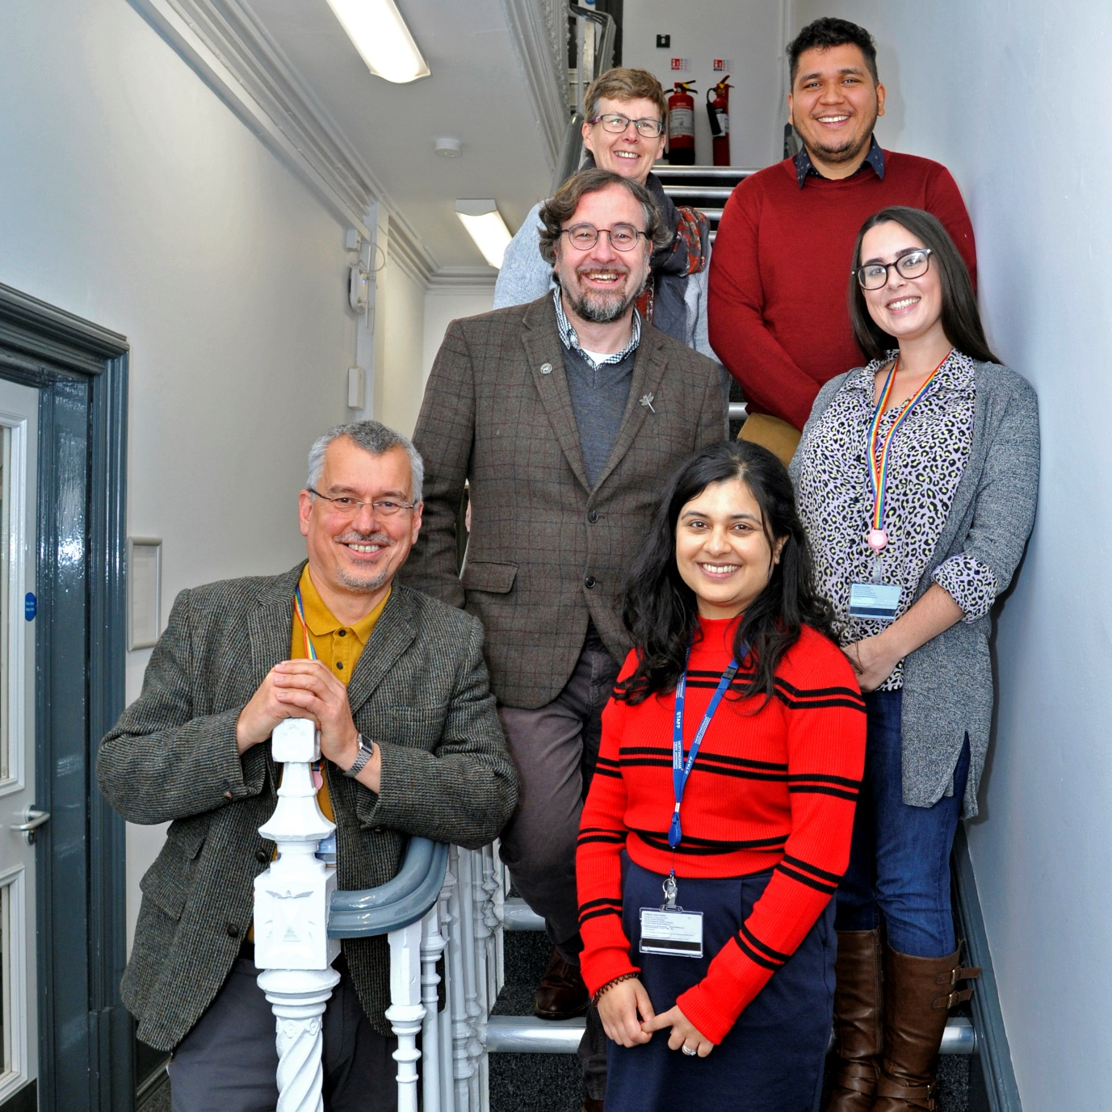
Left to right: Tony Churchill, Erin McDaid (Nottinghamshire Wildlife Trust), Deena Ingham, Kelly Trivedy, Erick Morataya and Jenny Hambling

Erin McDaid from Nottinghamshire Wildlife Trust was there to receive the £200 donation and says, “it’s great to see NTU supporting causes that are close to everyone in our community. Sustainability, wellbeing and the environment have always supported each other so it’s fantastic that Green Rewards is involved too.”
Since the launch of the Green Rewards programme over 35,000 positive actions have been taken to boost sustainability and wellbeing, saving 33 tonnes of CO₂ emissions. The new academic year saw rollout of Green Rewards to its 30,000 students now with a termly £200 charity donation for the whole of NTU to get involved with.

-Ends-
For further information contact: Sadie Hodgson at sadie.hodgson@teamjump.co.uk or call 020 7326 5055
Jump is the UK’s leading supplier of engagement programmes that boost sustainability and wellbeing. Working with companies, universities and the public sector to motivate individuals to take positive steps, clients include Manchester University NHS Foundation Trust, Barclays, Camden Council, Scottish Courts & Tribunal Service, University of Bristol and Aberdeenshire Council. For more information about Jump, see www.teamjump.co.uk.

