Press Release
For immediate release
Recycling by residents generates £6,000 for local charities through St Helens Recycling Rewards
Three local charities in St Helens have received donations on behalf of residents earning points for their recycling through St Helens Council’s Recycling Rewards initiative.
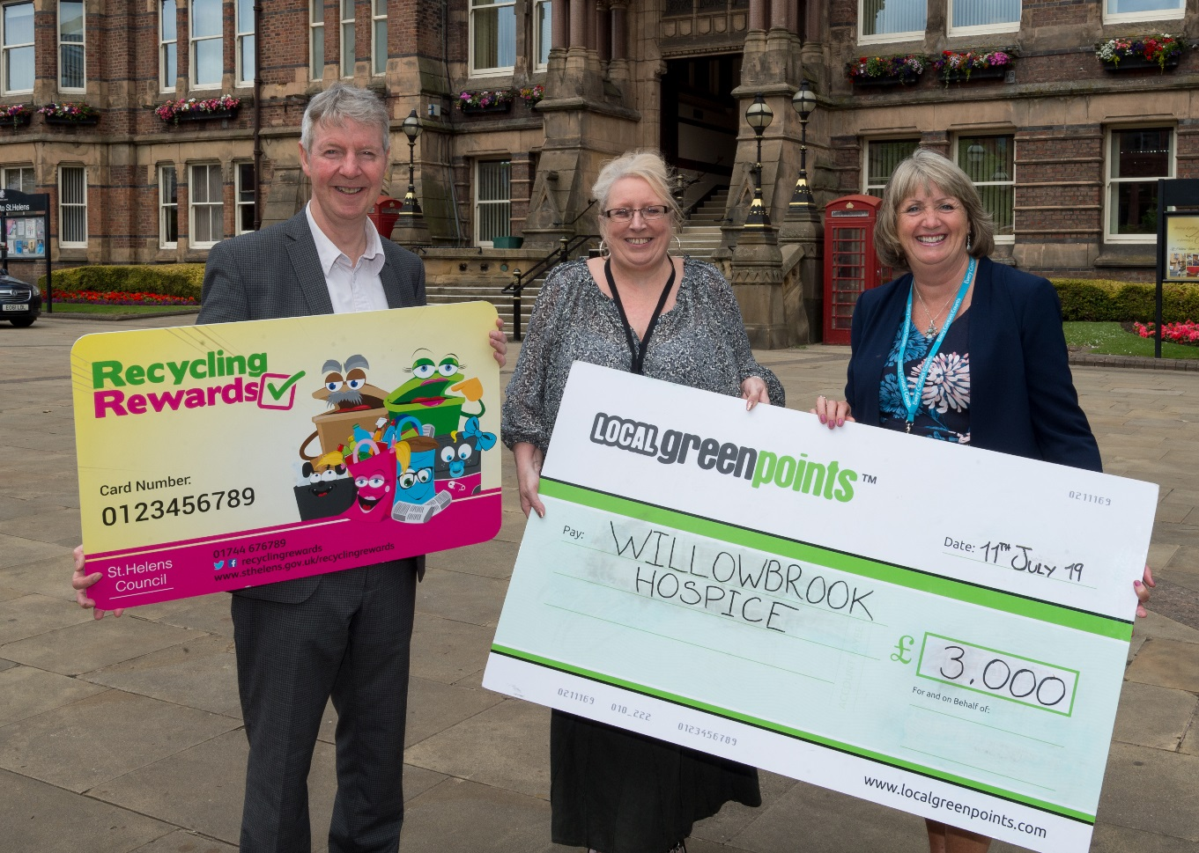
Residents from 16 communities across St Helens have been earning Green Points for their recycling actions, with each community competing for a share of the annual charity donations. This year Rainford Ward secured first place and chose to donate their £3,000 to Willowbrook Hospice. St Helens Mind received £2,000 from residents in Rainhill and the remaining £1,000 was donated to St Helens Carers Centre on behalf of residents in Billinge & Seneley Green.

Photo: Willowbrook Hospice received £3,000 at last week’s photocall at St Helens Town Hall.
L – R: Graham Simmonds (Chief Executive, Jump), Councillor Lynn Clarke (Cabinet Member for Environmental Services) and Nicky Saunders (Fundraising Manager, Willowbrook Hospice).

Launched in November 2016, St Helens Recycling Rewards is a partnership initiative between St Helens Council and Local Green Points, now known as Jump. The scheme rewards residents with ‘Green Points’ for recycling more and wasting less. As well as recycling, residents are encouraged to participate in waste minimisation activities such as the five step Food Waste Challenge and to use the Council’s garden waste and textiles collection services. Prizes of £50 and £25 vouchers are awarded on a monthly basis to the top recyclers, with voucher choices including National Garden Gift vouchers.
With more than 65 residents a month signing up, there are now 11,500 residents participating in the scheme with an average 5,500 positive actions carried out each week. Recycling Rewards is driving positive behaviours among St Helens residents, and the borough’s recycling rate is currently at 41.5 per cent, up from 38.9 per cent for 2016-17. Last year, 3,000 tonnes of food waste in St Helens was diverted from landfill and the council has recently extended the range of plastics it collects for recycling in response to demand from residents.
Councillor Lynn Clarke, Cabinet Member for Environmental Services, said: “St Helens Recycling Rewards is having a really positive impact on recycling amongst our residents and it’s fantastic to see the efforts of our residents also raising much needed donations for local causes – a real win-win!”
Nicky Saunders, Head of Fundraising at Willowbrook Hospice, commented: “We're so grateful to St Helens Recycling Rewards and everyone who voted for us to receive £3,000 from the charity pot! Your donations will help us hugely as we continue to care for patients with limiting diseases living in St Helens and Knowsley.”
Graham Simmonds, Chief Executive at Jump who operate the scheme in partnership with the Council, said: “We work with a number of local authorities across the UK and in our experience St Helens’ residents are one of our most engaged communities, as illustrated by an amazing 5,500 positive actions recorded weekly through the St Helens scheme.”
St Helens residents can sign up to Recycling Rewards for free by visiting https://sthelens.localgreenpoints.com/.
If you’re a local retailer and would like to get involved please call Jump contact centre on 020 7326 5055 or email info@teamjump.co.uk.
-Ends-
For further information contact: Maya Comely at Jump on info@teamjump.co.uk or call 020 7326 5055.

Jump is the UK’s leading supplier of engagement programmes that boost sustainability and wellness. Working with companies, universities and the public sector to motivate individuals to take positive steps, clients include Manchester University NHS Foundation Trust, Camden Council, Scottish Courts & Tribunal Service, University of Bristol and Nationwide. For more information about Jump, see www.teamjump.co.uk.

