Press Release

22nd May 2019

University of Chichester’s Jump Awards celebrates its 5th year

The University of Chichester held its annual Jump Awards on 9th May at its Bognor Regis campus to celebrate another successful year. Jump is a behaviour change programme motivating employees and students at the University to practise positive behaviours which boost sustainability and wellbeing. The programme is now in its 5th year, which makes it the longest-running Jump university programme in the country.

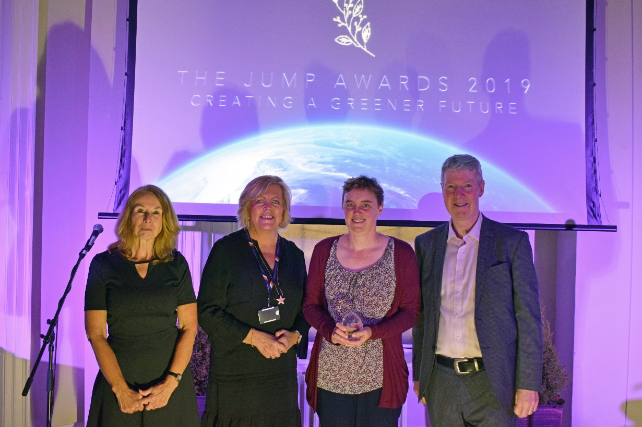
Photo: University of Chichester Jump Awards Ceremony.

L - R: Kate Cathie (Environment and Sustainable Development Co-ordinator, University of Chichester), Elisabeth Whitaker (Chief Human Resources Officer, University of Chichester), Jo Parker (Jump Champion 2019, University of Chichester) and Graham Simmonds (Chief Executive, Jump).

Since launching in October 2014, over 300 members of staff and students have signed up to Jump. The programme encourages individuals to get involved with sustainability and wellbeing behaviours including avoiding plastics, travelling actively, saving energy, leaving your car behind, recycling and taking positive actions. Members earn ‘Green Points’ for taking part through the Jump web platform or app, with prizes for the teams and individuals who earn the most points. Staff and students also earn points for ‘teamwork’ activities, in line with the university’s sustainability ethos of creating a culture of environmental awareness and community.

The annual Jump Awards ceremony, organised by second year Event Management students for their assessed project, celebrates the programme’s achievements. This year, both top performing staff, students and teams received awards, with IT Services receiving £500 and a Jump trophy as the winning team. Between them the team spent over 126,000 minutes walking, avoided almost 1,400 single use plastic items and had over 2,000 disposable cup-free days. Student Recruitment and Admissions came second place, receiving £250 and Academic Quality Standards Service, Executive Team, Psychology and Counselling and Estate Management, who came third, received £150. The individual nominated for their huge contribution to Jump this year, was Jo Parker who was crowned Jump Champion 2019 at the glittering Awards ceremony.

Elisabeth Whitaker, Chief Human Resources Officer at the University of Chichester, said: “Our annual Awards Ceremony is key for engaging our people in Jump and celebrating the positive steps taken by our people. With over 5,000 students and 1,000 members of staff, our activities can have a large impact on our local and global environment, and we are committed to creating a culture of environmental awareness throughout our community.”

Kate Cathie, Environment and Sustainable Development Coordinator at the University of Chichester, said “Universities now are all about student experience and employability, and we work hard to bring these elements into our Jump programme. The brilliant thing is that we get new faces every year! Our 5th Jump Awards ceremony was a great success and testament to the professionalism of our Event Management students - we look forward to many more.”

Graham Simmonds, Chief Executive at Jump, presented the Jump Champion 2019 Award to Jo Parker and said: “As the longest running Jump university programme in the country, it’s exciting to see the University of Chichester continuing to build momentum and introduce new activities such as IEMA membership for its Jump student ambassadors; and looking ahead the new dedicated Jump app for the University should boost engagement to even higher levels in the coming academic year.”

-Ends-

For further information contact: Maya Comely at Jump on info@teamjump.co.uk or call 020 7326 5055.

Jump is the UK’s leading supplier of engagement programmes that boost sustainability and wellness. Working with companies, universities and the public sector to motivate individuals to take positive steps, clients include Manchester University NHS Foundation Trust, Camden Council, Scottish Courts & Tribunal Service, University of Bristol and Nationwide. For more information about Jump, see www.teamjump.co.uk.

