Press Release
21st May 2019

Camden charities receive £5,000 through Council’s Recycling Rewards scheme
Five local charities in Camden have received a share of £5,000 on behalf of residents earning Green Points through the Borough’s Recycling Rewards scheme.
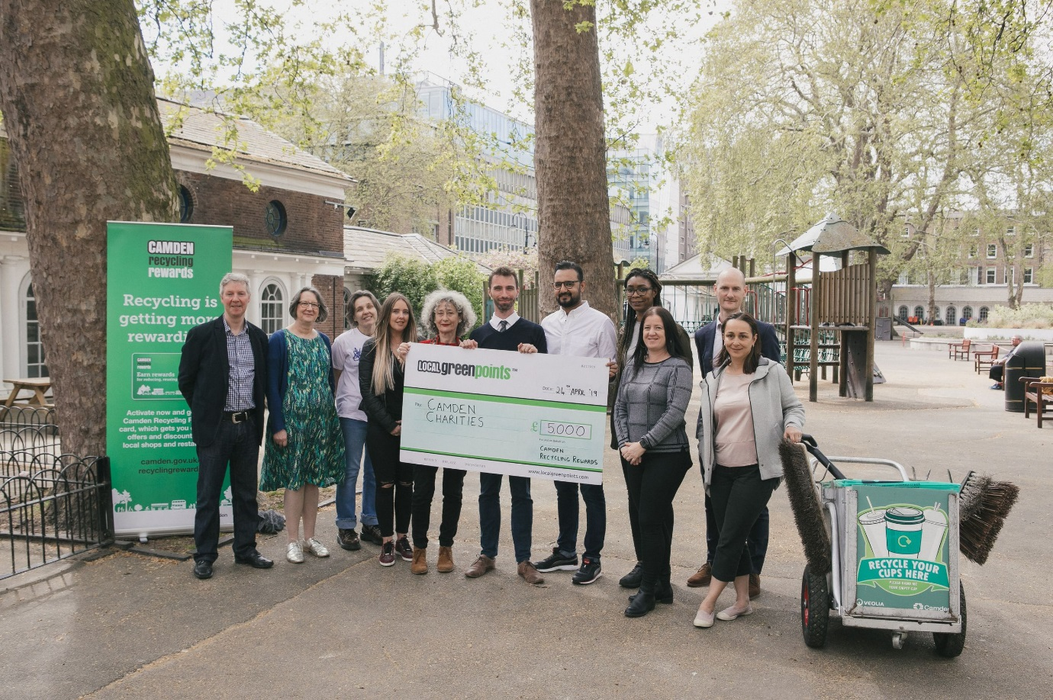
Photo: The five Camden charity partners receive their donations from Cllr Adam Harrison.
L-R: Graham Simmonds (Local Green Points), Jenny Tilley (Mind in Camden), Sharley Peet-Newitt (NW5 Community Play Project), Ester Caplin (Camden Music Trust), Cllr Adam Harisson, Karim Hussein (Cancer Research), Alisha Lestrade (NW5 Community Play Project), Kate Humphrey (Coram’s Fields Out of School Club), Richard Bradbury (Camden Council), Polly Markandya (Veolia).
The scheme – which launched in 2016 in partnership with Local Green Points - has seen over 16,700 households sign up to earn Green Points for their recycling efforts. Through the Recycling Rewards website and app, residents are encouraged to take steps to throw away less and recycle more. Residents earn points for actions such as repairing and upcycling, ordering recycling containers, composting or taking part in the ‘Food Waste Challenge’. Recycling and waste tonnage data is also used to reward communities.
Every 6 months, the community with the most Green Points wins the biggest share of £5,000, to donate to one of five local charities and community projects. Members vote for the cause they'd like to receive the biggest share of the donation pot, with the amount of money received depending on how many votes each charity gets. The winning community, North East, voted to donate £2,500 to Mind in Camden. Cancer Research received £1,500, Coram’s Fields Out of School Club received £500 and both NW5 Community Play Project and Camden Music Trust received £250.
Recycling Rewards recognises top performing individuals, awarding a £30 voucher to the resident who earns the most Green Points in each community each month. Residents that sign up to the scheme also receive a discount card which can be used in over 100 local businesses across Camden. Now that the scheme has been running for three years, over 145 vouchers have been awarded and over £25,000 donated to local charities.
Cabinet Member for Improving Camden’s Environment, Councillor Adam Harrison, said: “Engaging and rewarding residents is vital to keeping Camden clean and to meet our recycling targets. The Camden Recycling Rewards scheme provides benefits for our households and communities for their efforts to reduce, reuse and recycle. Whether residents are reporting their recycling or organising community clean ups, the scheme not only gets residents on board with recycling but also with raising money for local charities.”
Jenny Tilley, Mind in Camden, said: “Once again we owe our gratitude to the Camden Recyclers who voted for us! And once again the prize for us is not just a huge cheque for £2,500 but also the knowledge that we are so well thought of by the residents of this forward thinking green borough. We are so happy to be part of this scheme and so proud to be Camdenites! We send our love to everyone who has transformed their recycling habits by being part of the Green Points recycling community and we pledge to do our best to encourage others to join in in our final six months as a nominated charity. This generous donation will be put to good use in our mental health services - thank you so much everyone!”
-Ends-

Notes for editors

Camden Recycling Rewards

Camden Recycling Rewards is administered by Local Green Points on behalf of Camden Council. In addition to supporting charities, it offers residents the following incentives:
- Members of Camden Recycling Rewards benefit from offers in nearly 100 Camden businesses.
- Each month, a £30 voucher is given to the top recycler in each of the five Camden communities.
- Scheme members earn ‘green points’ for recycling, log their green points online and choose which of five charities they want to get their points. Every six months £5,000 is divided between five charities.
Residents can participate in Camden Recycling Rewards for free by activating their accounts online at camden.gov.uk/recyclingrewards or over the phone on 020 7326 5055 (Mon to Fri, 9am to 5.30pm)
About Local Green Points:
Local Green Points is an LLP company backed by Green Rewards, the UK’s leading supplier of sustainable rewards programmes. The Company provides a range of services to local authorities that encourage waste reduction, recycling and reuse, and its local authority clients include the London Borough of Hackney, London Borough of Camden, London Borough of Bexley, The Royal Borough of Kingston upon Thames, St Helens Council, Westminster City Council and many more. Its parent company, Green Rewards, operates the workplace sustainability programme, Jump, and its clients include Aberdeenshire Council, Manchester University Foundation NHS Trust and the University of Bristol.
localgreenpoints.com

